**Department of Computer Science and Engineering**

|  |  |
| --- | --- |
| **Course Code: CSE 321** | **Credits: 1.5** |
| **Course Name: Operating Systems** | **Semester: Fall 18** |

**Lab 04  
CPU Scheduling**

1. **Overview:**

**CPU scheduling** is a process which allows one process to use the **CPU** while the execution of another process is on hold(in waiting state) due to unavailability of any resource like I/O etc, thereby making full use of **CPU**. The aim of **CPU scheduling** is to make the system efficient, fast and fair.. In this lab students will learn the concept of CPU Scheduling and Implement the different Scheduling Algorithm.

1. **Lesson Fit:**

Programming knowledge is required for this lab.

1. **Learning Outcome:**

After this lab, students will know the how Different Scheduling Algorithm works, be able to Scheduling using multiple processes.

1. **Anticipated Challenges and Possible Solutions**
   1. When interaction occurs among processes, sorting, loop condition, variable problems arise.

**Solutions:** Students should have the knowledge about previous algorithm labs.

1. **Acceptance and Evaluation**

Students will show their progress as they complete each task. They will be marked according to their lab performance.

**Activity Detail**

* 1. **Hour: 1  
     Discussion:**

1. Discussion on CPU scheduling and how it works.
2. Why CPU scheduling is important and its benefits
3. How we can implement those scheduling algorithm.
4. Discussion about First Come First Serve CPU Scheduling Algorithm.
5. How FCFS algorithm will implement on java programming.
6. **Waiting time:** Processes need to wait in the process queue before execution starts and in execution while get preempted.
7. **Turnaround time:** Time elapsed by each process to get completely served. (Difference between submission time and completion time).
8. Find Waiting time, Turnaround time and Response time for each process.
   1. **Hour: 2**
9. Discussion on Non-preemptive concept of CPU Scheduling.
10. How Shortest Job First algorithm works.
11. Make an Example to implement the concept of Non-preemptive.
    1. **Hour: 3**
12. Discussion on Preemptive concept.
13. Implementation of Preemptive Shortest job First CPU scheduling and find waiting time and Turnaround time for each process.
14. **Home tasks**

Create 10 processes with different Burst time and Arrival time. Then implement the concept of first come first serve, preemptive and non-preemptive scheduling algorithm. Calculate Response time , Turnaround time, Waiting time and find which scheduling algorithm is best for the given data.

**Lab Activity List**

**Task 1 –(FCFS Scheduling Algorithm)**

Here the processes are arranged in order of their increasing arrival time. Check for incoming processes after the completion of the current process.

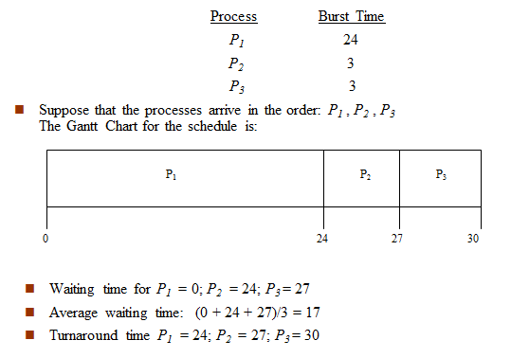

**Task 2 –(SJF Scheduling Algorithm-Non-preemptive)**

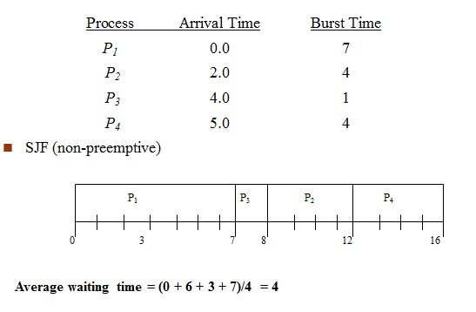

[You have to use the Same Skeleton Code given for FCFS Scheduling but you have to sort the process according to its Time]

**Task 3–(SJF Scheduling Algorithm-Preemptive)**

Create five processes with given Arrival time and Burst time. Calculate Avarage waiting time for the Preemptive SJF.

